Product Description
Polyester Solutions Ceiling baffle is light weight insulation manufactured using thermally bonded polyester fibre, with a high percentage of recycled fibres. Polyester Solutions Ceiling baffle acoustic insulation and is manufactured to comply with AS/NZS 4859.1 Polyester Solutions Ceiling baffle is designed for use above new or existing weighted sound reduction index (Rw) rated partition walls to enhance the acoustic privacy between office spaces.

Applications
Polyester Solutions Ceiling baffle is a non-irritant acoustic insulation material designed to be layer stacked above partition walls to significantly reduce sound transmission through the ceiling plenum space. Polyester Solutions Ceiling baffle is incredibly easy to install and will mould itself around ducting and services, eliminating gaps and holes as potential sound paths

Standard Sizes and Packaging

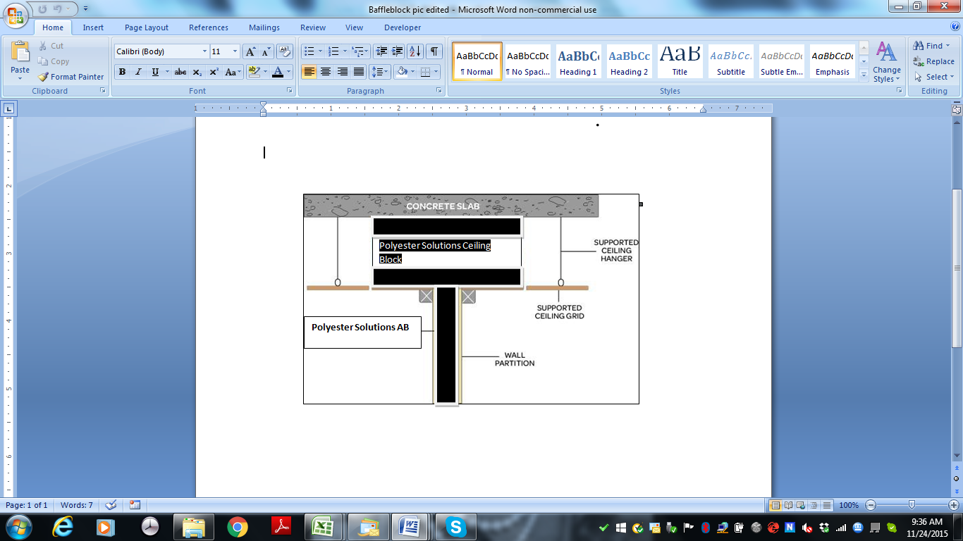  PRODUCT | THICKNESS  (mm) | WEIGHT  (gsm) | PACK SIZE
Polyester Solutions Ceiling baffle | 100 | 1000 | 600mm wide x 8.33Lm x 2 Rolls per Pack (10m²)  Or  600mm x 1200mm x 8per pack (5.76m2)

Acoustic performance
Polyester Solutions Ceiling baffle will provide improvements of STC16-22 depending on the stack compression, installation quality and specification. Ceiling path sound transmission without a ceiling baffle system is typically Rw 30 assuming the use of common mineral-fibre ceiling tiles in a standard suspension system. Polyester Solutions Ceiling baffle installed at minimum compression in the same system will increase the rating to Rw 44. Increasing the Polyester Solutions Ceiling baffle stack compression to 30% and installed density to 14kg/m³ will increase system performance to Rw 50

Fire Resistance
When tested in accordance with AS1530.3 (1999), “Early Fire Hazard Properties of Materials”, PSB exhibit the following characteristics:
Ignitability Index 0
Spread of Flame Index 0
Heat Evolved 0
Smoke Developed Index 0 - 3

Moisture Resistance
Exposure to an atmosphere of 50˚C and 95% relative humidity for 4 days results in less than 0.2% by vol moisture absorption.

Maximum Service Temperature
The maximum temperature to which Polyester Solutions Ceiling Baffle should be exposed in service is 150˚C.

Environmental and Health Benefits
Recycled Fibre Content 80% Minimum
Volatile Organic Compounds (VOC’s) No harmful VOC’s
Formaldehyde Content Nil
Phenol Content Nil
Ammonia Content Nil
Ozone Depleting Potential (ODP) Nil
Chloride Content Nil
Total Recyclable Content 100%

How to Specify
The insulation material shall be Polyester Solutions Ceiling Baffle

General Installation Advice
Polyester Solutions Ceiling Baffle must be installed with at least enough compression to ensure stack stability and a tight fit to all surfaces including slab, roof or floor above. No gaps to be allowed through the stack. Polyester Solutions Ceiling Baffle can be installed to a height of 1m without specialist design considerations. Above this height consideration must be given to the stack stability and weight loading restrictions on the ceiling tiles and grid system. Other options are available for plenum heights above 1m. Where the ceiling plenum is used as an active return for the air conditioning system ensures airflow is not significantly reduced. Polyester Solutions recommends you consult the Mechanical Services Engineer to ensure the use of Polyester Solutions Ceiling Baffle will not result in a loss of effective air movement. Existing services, ducting, ceiling grid supports and fire control and detection devices must not be affected by the installation of Polyester Solutions Ceiling Baffle. Polyester Solutions Ceiling Baffle should not be used where temperatures exceed 160ºC. Where flues or similar heat emitting items pass through the insulation, a 150mm venting gap should be left between that item and the insulation.

Testing

All testing was conducted in a laboratory situation. On site results may vary due to site conditions and quality of installation. Thermal testing is done in accordance with AS/NZS 4859.1(Materials for the thermal insulation of buildings - General criteria and technical provisions) and acoustic testing in accordance with AS 1191(Acoustics - Method for laboratory measurement of airborne sound transmission insulation of building elements). As these products are constantly being researched and developed, we reserve the right to update these specifications without notice.

